Observations and Report of the Short-term Fellowship Granted by EBCOG

I am Murat Yassa, I was 6 months far to finish my residency in Fatih Sultan Mehmet Training and Research Hospital of Health Ministry University, a well-established educational hospital in Istanbul, Turkey with around 3600 births per year.
I was one of the two awardees’ of “European Board & College of Obstetrics and Gynecology (EBCOG) short-term fellowship scholarship” for 2017. I spent three months in National Maternity Hospital (NMH), Dublin, Ireland between September and November. I feel very grateful to EBCOG and European Network of Trainees in Obstetrics and Gynecology (ENTOG) executives to provide me this one of the greatest experience of my life.
I had great time in NMH in every aspect. Firstly, I must specially thank to Rhona Mahony, the current Master of NMH, not only a leader but very much loved by her team as well; her great support and understanding was priceless.
NMH could not provide accommodation, but it was only due to the limited space in the aged building, which is still greatly functioning. They are going to move to a very modern building in St. Vincent University soon. I believe that it would broad NMH’s horizon and opportunities.
The hospital has over 110 years of history and that reflects very well established protocols and you definitely feel that you are working in an experienced environment. NMH has around 6000 births per year which is one of the highest levels across all Europe.
Firstly, I spent most of my times in Obstetrics, the “Labour Ward” of NMH and the midwifery system is known with its excellence all over Europe.

Midwifery system in NMH
Midwives have different ranks while running a labour ward. Clinical Midwife Manager, a.k.a. “CMM” has huge access, flexible on her own to make decisions and can supervision the other midwifes. NMH provides one-to-one care to every patient. The handover is being done between midwifes and also with registrars. Midwives can see a patient on casualty (emergency department), can admit her to the hospital if she needs that it is necessary, induce the women with uneventful low-risk pregnancy with oxytocin, rupture the membranes, make the delivery done, suture the episiotomy and even discharge with basic prophylactic antibiotics; without a doctor’s involvement. Some midwifes with a particular training can even do the first-trimester ultrasound scan on their own and manage the situation. It sounded me very weird initially but I got fascinated when I see that the system actually works in excellence. I made a lovely interview with a CMM-2 (it means very senior) midwife, Ms. Martina Murphy, and I found out that midwives actually feel safe with running the labour ward in terms of medico-legal problems. The hospital provides medico-legal insurances. In addition, midwives have their own boss, separated than medical doctors. So, basically, labour ward is run by “midwives”, not by doctors. Respect for each woman’s needs is a rule in NMH and a common understanding among midwives. Uneventful pregnancies, which constitute the majority of all pregnancies, are all being managed by only midwives. Thus, obstetricians can more focus on the patients with special attention and it prevents excessive workload of trainees.
The hierarchy in the midwifery approximately works as follows:
- Midwife
- Clinical Midwife Manager (CMM) 1: Experienced midwife who applies a high level of clinical nursing knowledge, experience and skills in providing complex midwifery care. CMM-1s are always in a different coloured uniform and responsible from all labour ward for that time of period. They do not stay in a patient room and take care of one pregnant but they are responsible from all labour ward. The midwives consult to CMM1 first before obstetricians so they can get the decision of oxytocin or to let the registrar know about the emergent situation. CMM 1 handover the clinical round to obstetricians. It takes generally 3 to 4 years of post-registration experience.
- CMM 2, CMM 3 and eventually Clinical director of midwifery posts involve in more non-clinical duties. CMM 2 exercises extended autonomy of decision making and more importantly exhibits leadership in the service delivery in the labour ward with focusing on findings solution for the midwives.
Some midwives can be certified in 1st trimester scanning with ultrasound as well as 2nd trimester detailed scan. There are many well-experienced midwives that have those certificates and work in casualty and antenatal units. This issue reduces the excessive workload on obstetricians’ shoulders.
Midwifery in NMH, It affects everything; the mean of vaginal examination is only 3.3 times per patient (ref. Dr. MS. Robson). The number of official complaints of patients was between three or five for last year (ref Clinical Director of Midwives, Ms. Mary Brosnan). With the shared workload between doctors and midwives, the doctors can actually spare more and more time to patients. In my country, the average time that a doctor can have for a patient is five minutes at most. A good communication, courtesy and happiness seem as the key.

Unforgotten tools to reduce CS rates
NMH is also known to have a good pediatrics and anesthetics department. They have a substantial success in preterm pregnancies and infants with syndrome (sadly, abortion and termination are still forbidden in Ireland). The collaboration co-operation between Obs&Gyn, pediatricians and anesthetics is worthy of respect. This also helps very high epidural rates. Pain management with epidural is provided almost for every clinically safe pregnant. In addition, the proper use of Fetal Blood Sampling (FBS) which is abandoned in Turkey in reality would help to substantially reduce the Cesarean Section rates (CS). The other procedure to mention is external cephalic version (ECV). All the patients with breach presentations are being offered for ECV procedure. It is held in once a week with a detailed consent. The excellent midwifery affects the use of instrumental delivery too, which is common in NMH and by done every registrar liberally. I also had the chance to give a try for those procedures in a NMH tradition.
In brief,
- Providing a proper pain management with epidural anesthesia for every consented women
- Trial of an External cephalic version (ECV), in order to reduce Category 6 and 7 of Robson Classification
- Fetal blood sampling (FBS), in the presence of a pathological fetal heart rate trace unless there is clear evidence of acute compromise
- Liberal use of forceps
- One-to-one care
- Safe medico-legal environment for midwives and obstetrician
might be the 6 most important elements in order to reduce cesarean section rates in Turkey and many countries.

GBS Screening
In contrary to the latest guidelines as the universal bacteriological screening is not recommended anymore, they still keep doing GBS screening in their routine practices. I believe it helps to reduce the used amount of antibiotics in pregnant. I believe they should present their experiences with GBS screening.
Referral system in Ireland
It is difficult to find an appointment (mostly gynecologic cases, pregnant are exempted) to get examined in a public hospital. In reverse, it is very easy in Turkey, an appointment can be found in same week. Although it sounds better, it results with excessively crowded outpatient daily schedule. Appointments are usually given in every 5 minutes that leaves no time to discuss the medical situation or consent in detail. In addition, the referral system is quite different in Ireland compared to Turkey. Patients are majorly referred by general practitioners (GPs) to the maternity hospitals and regular checks are being done by GPs. Contrarily, patients do not need to have referral from their GPs to be able to get examined by Obs&Gyn specialists. Although it sounds as easiness for the patients, it only consumes the time that should actually belong to patients in real needs to see a specialist. In summary, patients may wait for months to get an appointment in Ireland, but they are well aware that they will get a high quality of care eventually with also proper duration of examination for themselves.

Self-audit
Beside the excellent midwifery system and liberal use of instrumental delivery; I have fascinated with one other thing: the self-educations (a.k.a. audit – ref. MS Robson). A meeting is held at 07:30 every morning which takes around 30mins. There are another meetings starting at 12:00 in one or two days every week. The meetings consist of “CTG Meetings, Perinatal and Fetal medicine meetings, Antenatal meeting, Clinico-pathology meetings”. Consultants from all departments, directors, midwives and doctors briefly discuss the in-patients, high-risk pregnancies, instrumental deliveries, interesting cases, pregnancies with abnormalities, weekly C-section rates as well as all CTG’s of every primigravid C-section cases are being reviewed case by case and questioned the clinical relevance. In addition, registrars weekly present a presentation on specific topics.

Educational Courses
I had the honour of participating to a few courses including: Dublin Leadership Course, Active Management of Labour Course, Multidisciplinary Emergency Drills & Skills Workshop and the Managing Medical Obstetric Emergencies and Trauma Course (mMOET) during my short-term fellowship in Dublin.
Dublin Leadership Academy was held from September 20th to 22th in NMH by a team (Dr. Michael Foley, Dr. Dan O’Keeffe, Dr. Idalynn Karre) from the Society of Maternal Fetal Medicine (SMFM).
Active Management of Labour Course was held in the NMH from October 25th to 27th 2017 by Dr. Michael Robson, Dr. Declan Keane and Ms. Martina Murphy by a wide ranged attendees from 12 different countries.
Multidisciplinary Emergency Drills & Skills Workshop was held on 17th of October by Dr. Mary Higgins and Dr. Ingrid Browne about the management of the most common obstetric emergencies (such as postpartum hemorrhage, eclampsia seizure, sepsis in pregnancy and maternal collapse) with scenarios on models.
mMOET Course was held and certified in Belfast, Northern Ireland from 16th to 17th of November 2017 at 3fivetwo Training Academy organized by Advanced Life Support Group.

Active Management of Labour (AML)
The concept of active management of labor was first implemented by O’Driscoll and colleagues at the National Maternity Hospital in Dublin in 1968 and now maintained by MS Robson and Declan Keane. I believe this approach needs a special attention and one of the things that I feel that I am very lucky to learn about. Main idea and philosophy of AML is simple: “Prevention of prolonged labour” and therefore reduce the psychological and physiologic burden of the pregnant. AML contains both organizational and medical components with physicians supervising normal spontaneous labor in nulliparous women and intervening only when labor progress slows. Organizational components include: Antenatal education, one-to-one care and audit of the outcomes. Medical components include: Strict diagnosis of labor, early amniotomy, high-dose oxytocin for dystocia (if no contraindication) and liberal use of epidural analgesia.
Diagnosis of labour is very innovative in AML and in NMH practice. It is a hard concept to fully understand in the beginning. Patients are not admitted to the delivery unit unless they meet the strict diagnosis of labor. Complete cervical effacement regardless the cervical dilatation is the key of the definition. To mention about cervical dilatation is not applicable prior to a fully effaced cervix, but only cervical length is relevant. Fully effacement often comes with painful, regular uterine contractions, bloody show, with or without rupture of membranes.
Early amniotomy is performed at admission after obtaining consent to every nulliparous woman at uncomplicated term gestations with a fetus in the cephalic presentation. The aim are to assess the volume and color of the fluid. If there is meconium or a scant amount of fluid present, pointing oligohydramnios then the patient is accounted as not eligible for higher-dose oxytocin augmentation. Early rupture of the membranes also results with shorter labour.
After the diagnosis of labor, the patient must progress 1 cm/hour based on cervical examinations performed in 2 hours. If cervical dilation does not progress at this rate, oxytocin is being started for the diagnosis of dystocia. Twelve hours is the accepted maximum safe limit of the duration of spontaneous labor, and if delivery was not eminent after artificial rupture of membranes and oxytocin administration, cesarean section was considered.
The AML seems very efficacious and majorly reduces the prolonged labour. From my point of view, one of the main advantages of AML concept is hastening the circulation in delivery ward and thus the labour rooms and midwives are always enough even for the high volume of deliveries.

Additions
I also spectated a laparoscopy sacrocolpopexy in St. Vincent University performed by a great urogynecologist, Dr. Gerard Agnew. It was Dr. Agnew’s courtesy that he allowed me to be involved in some colporraphy anterior/posterior and vaginal hysterectomy operations. Dr. Declan Keane, a great teacher, former Master of NMH / urogynecologist, also let me to be involved in similar urogynecologic operations. I observed an ultrasound-guided haemotransfusion in a TTT syndrome in antenatal units. I also joined to Dr. Rhona Mahony during her 2nd trimester detailed scanning. I also spent time in colposcopy unit.

Scheme of an Obs&Gyn trainee in NMH
As a trainee and almost a specialist, I have to mention about the working conditions of trainees and midwives, trainee education and becoming a consultant.
Internship is being done for one year after the completion of the medical faculty. The general trainee education can be summarized as Basic Specialist Training (BST) + High Specialist Training (HST). BST programmes vary in duration from 2‐4 years which usually take three years in Obstetrics and Gynecology. Following the internship, BST consist of 2 years of Senior House Officer (SHO) and 1 year of Junior Registrar (J-Reg). Entry into BST is competitive in Dublin. The process is being assessed annually. For instance, Year 1 BST assessment was held on 14th of November.
A senior house officer (SHO) is a non-consultant hospital doctor in Ireland. SHOs are supervised in their work by registrars and consultants. A SHO performs a wide variety of clinical, clerical and teaching tasks. J-Reg is an intermediate form between SHO and entry to HST.
The duration of HST ranges from one year to six years in different specialties. It usually takes 5 years of HST in Obstetrics and gynecology. A trainee is usually called as Specialist Registrar (SpR) during the HST program. A SpR intensely assist the wide variety of gynecological surgeries and even perform under the supervision.
In comparison with Turkey, it takes a lot (around 8 years) to become a specialist in Ireland; however, it takes only 4 years in Turkey. The probable explanation for this divergence might be the working conditions and working hours. While a trainee has three to five night shifts per month in NMH, it starts with 10 nightshifts per month and end with 7 in my current hospital. Besides, trainees start to nightshift at 16.30 and finishes with 07.30 in the morning with post-call leave. Contrarily trainees start to a day routinely in the morning, have the nightshift on same day and continue to work the other day without a post-call leave in Turkey.
Some may say that much of excessive workload and long work hours toughen the trainees; but it obviously makes impossible to have sincere doctor-patient relationship and reduce the quality of care. Trainees are lucky not to be involved in uneventful pregnancies in labour ward and as well as casualty (ermergency department) during the night shift.
The trainees change hospitals during their residency. They can do rotation in between the hospitals, some have excellent obstetrics as in NMH, some may have more developed gynecologic oncology unit, etc. In Turkey, residency programs are only held in medical faculties or training and research hospitals that are high-volume multidisciplinary facilities, thus, trainees only stay in one hospital/med faculty during the residency program.

Conclusion
I benefited a lot from my short-term fellowship in National Maternity Hospital which was a great experience that broaden my horizon. I enjoyed of every minute in Dublin. I deeply appreciate what EBCOG provided for me and look forward to see more of this kind of fellowship and/or exchange programs to continue to support trainees along with the efforts of standardizing the residency program of obstetrics and gynecology. I believe that I returned home with gaining many different perspectives that can make a difference around me. The EBCOG fellowship was an ideal experience and a great opportunity to get a different and valuable notion that I strongly recommend to all my colleagues who wish to gain insight mainly on every aspects of obstetrics.
Dr. Murat Yassa
Department of Obstetrics and Gynecology,
Fatih Sultan Mehmet Training and Research Hospital
Health Sciences University
Istanbul, Turkey
Member of Executive Board of
Turkish Trainees of Obstetrics and Gynecology (TTOG)
+90 533 5106312
murat.yassa@gmail.com

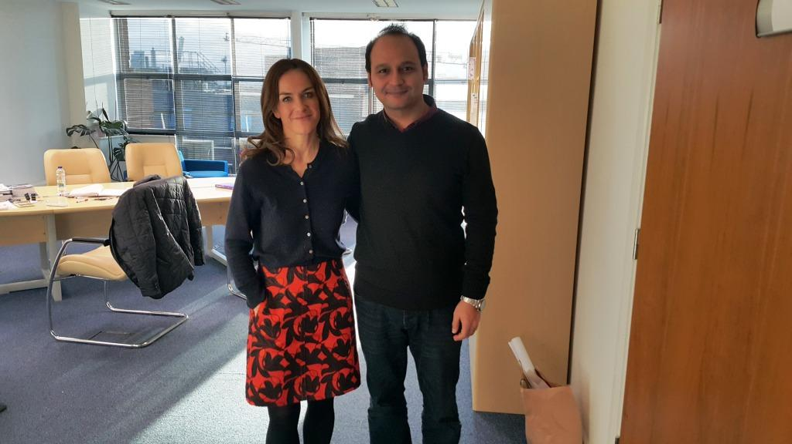
Rhona Mahony, MD., FRCOG., FRCPI., FACOG (Hon)., EF, DMed.
The Master of National Maternity Hospital

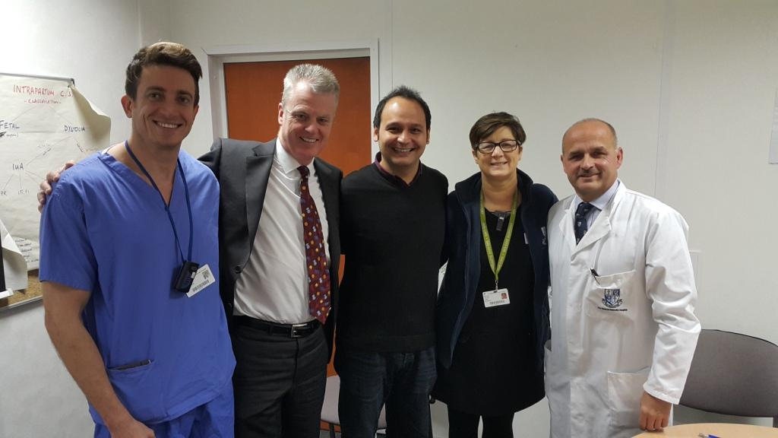
Left to right: Dr. Ahmad Haydar, International fellow from Switzerland; Dr. Declan Keane, Former Master, Urogynecology; Ms. Martina Murphy, Clinical Midwife Manager II; Dr. MS Robson, Former Master, Labour ward

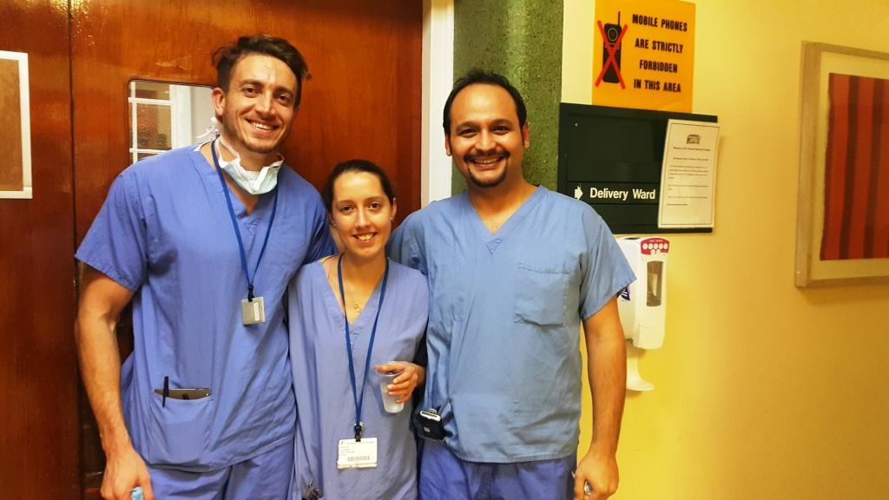
Nightshift in NMH, left to right: Dr. Ahmad Haydar, International fellow; Dr. Kate O’D, Registrar

