ENTOG-EBCOG Fellowship 2023
Final report

I would like to start by expressing my gratitude for the great opportunity of an ENTOG-EBCOG Fellowship, as it broadens our knowledge horizon, it builds up strong international networks, supports with foreign language development and it breaks barriers focusing on potential unconscious biases. I am Fabiana Interlandi, a 5th year resident doctor at the “Università degli studi Magna Graecia” in Catanzaro, Italy and one of the lucky three awardees of EBCOG short-term fellowship scholarship” for 2023. I spent three months in Thessaloniki, Greece, at the General Hospital of Thessaloniki Ippokrateio in the 2nd department where I had a robust learning opportunity in the department of Prenatal Diagnosis, Low and High-Risk Pregnancy, Benign Gynaecology, Gynaecologic Oncology, Breast Cancer under the coordination of the director the Professor Konstantinos Dinas and the Professor Alexandros Sotiriadis and the Professor Stamatios Petousis.
Instead, one day a week I attended the Papegeorgiou Hospital mainly dealing with infertility and benign surgery with Professors Gimbrizis for the part of benign surgery and Professor Zolumbianakis for the part of infertility.
In the following lines I will highlight the day-to-day experience.
General Hospital of Thessaloniki Ippokrateio
The department’s core activity includes both the obstetric part involving low and high-risk pregnancy, prenatal diagnosis for which Professor Sotiriadis is in charge, the oncological part both breast and gynaecological by Professor Dinas and Professor Petousis.
I followed the obstetrics part more as I have always been more interested in.
I will briefly outline the activities that are carried out in this hospital. On the obstetric side, there are three days dedicated to first and second trimester screening and ultrasound follow-up of high risk patients taken in charge, one day is dedicated to the management of new high risk patients with evaluation of laboratory tests and management of future appointments as well as inductions and admissions according to the situation, every day Professor Sotiriadis early in the morning takes care of following up the patients admitted assessing which is the best management according to the situation.
Professor Sotiriadis and his assistant Carolina have FMF diploma and are particularly well versed in the field of fetal medicine. They patiently explained each particular case to me, adhering to current guidelines and carefully studying each case to ensure the best maternal-fetal outcome.
Professor Sotiriadis is a highly regarded and recognised professional at national and international level, holding important positions in the most renowned scientific journals of obstetrics and gynaecology. In fact, he is a Reviewer for international scientific journals (incl. BMJ, Obstet Gynecol, Ultrasound Obstet Gynecol, BJOG,Cochrane Collaboration) and Member, Cochrane Collaboration, Pregnancy and Childbirth Group.
Apart from great knowledge in theoretical terms, he also has great practical and teaching skills. He takes care of the training of the residents as well as her fellow always constructively evaluating their progress. With me, he has always been careful to make me feel well integrated, a care that not everyone has and part of the cases by asking me what I thought too. I am grateful and honored to have known him and for all that he has taught me in these months. He truly takes care of his patients by studying for them and carefully evaluating what is the best strategy to help them. Observing his way of acting I learned a lot for my professional growth. One case in particular made me think in which it really changed the outcome of a now doomed pregnancy, guaranteeing a woman at least the possibility of saying she has tried everything. Anyone else would have given up, me first, not him. I will carry this along with many other teachings as a life baggage. I also really appreciated his way of relating to patients, always trying to have a smile and a hand on the shoulder on the most dramatic occasions, the same for his residents and fellow. He is truly a great professional.
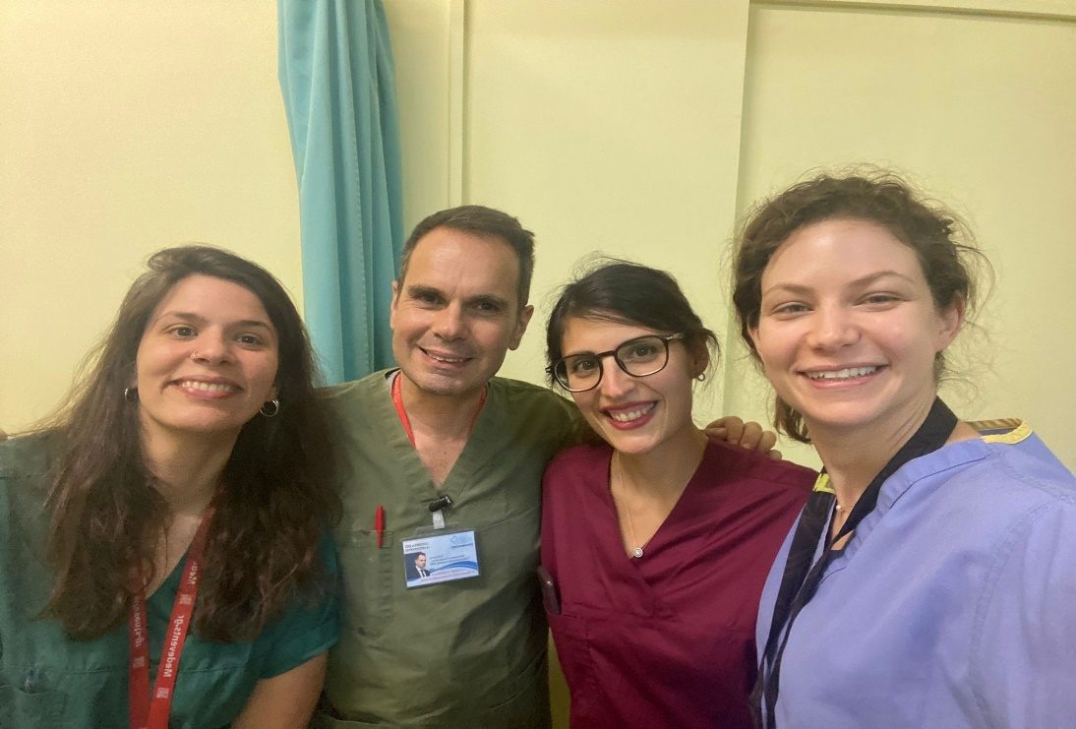
Carolina Theodoridou the professor's assistant has also been an angel for me, always being particularly attentive to every detail, explaining everything to me and helping me to obtain my FMF licence for Fetal Doppler, Cervical Assessment and Preeclampsia licence. I am grateful for having been well educated from a training point of view but I am also particularly grateful for the moral support I have had over these months. She was a great teacher for me but also a good friend with whom I hope to always maintain good relations.
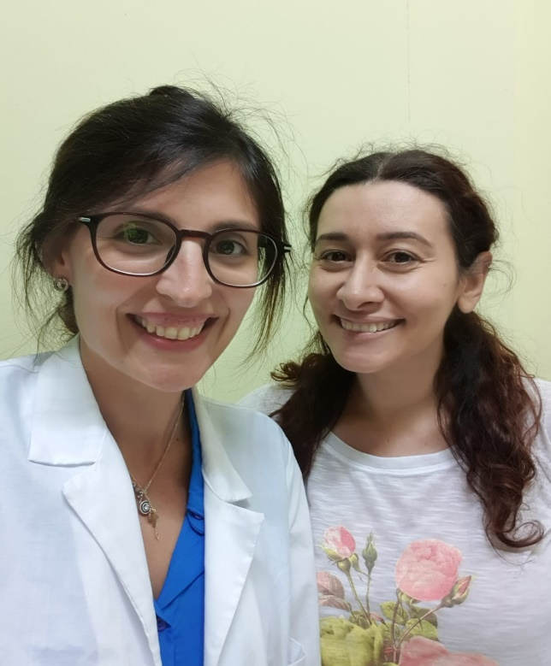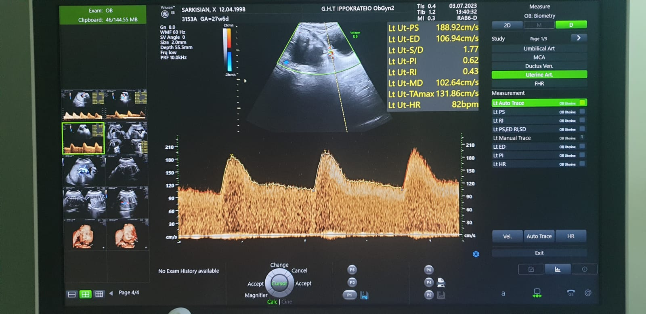
I was also particularly lucky to meet the fetal maternal fellow Elefteria and the residents Melpo, Dimitrula, Dimitra, Alexandra, Georgia, Emmanuela thanks to them I had my Greek family and I felt less homelessness than when you're abroad it usually is always well marked. We shared and learned a lot in the hospital updating each other on the various patients but we also shared many beautiful moments outside and thanks to them I had the opportunity to taste the most typical Greek dishes. I hope to always have them in my life and I will always be grateful for how they have made me feel appreciated and loved these past few months.
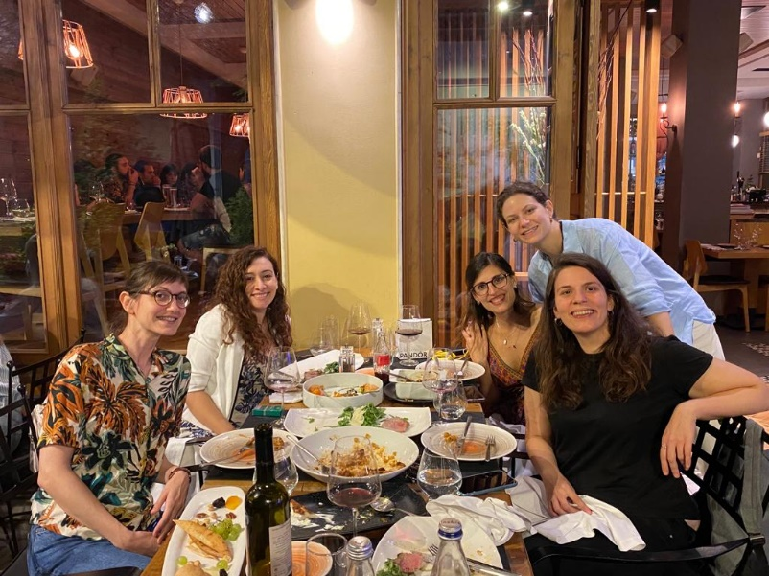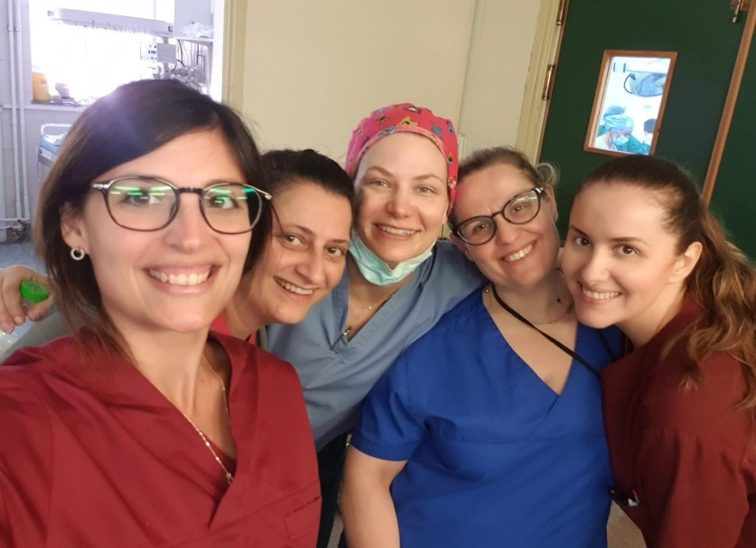
During the months there, there were quite a few very difficult cases also referred to in Greek as 'malakie' that came to us for observation, from severe pre-eclampsias, to infections in pregnancy, particular genetic syndromes, threats of preterm delivery, complicated twin pregnancies, previa placentas, accreta and percreta placentas, decompensated gestational diabetes that were managed in the best possible way,.
Apart from the ultrasound part, I also had the pleasure of being able to take part in the invasive diagnostics procedures by seeing amniocentesis and villocentesis, amnioreductions in case of polydramnios.
Regarding the management of the threat of preterm delivery I was fortunate to see many cerclages as well as the insertion of pessaries.

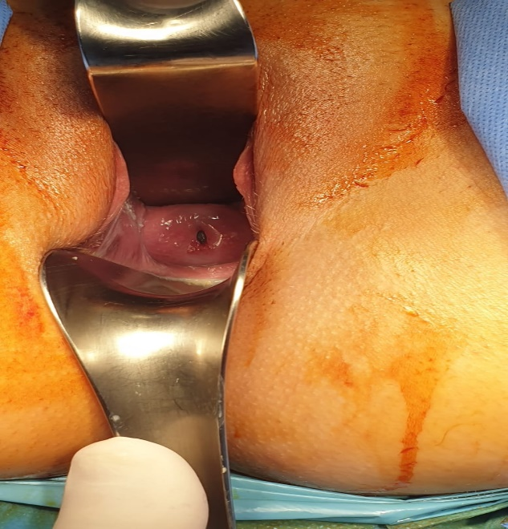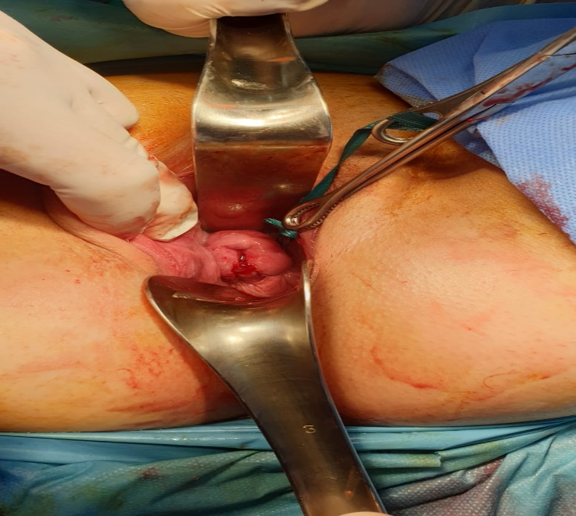
They also gave me the opportunity to participate in the most complicated caesareans for previa/ accreta/ percreta placentas.
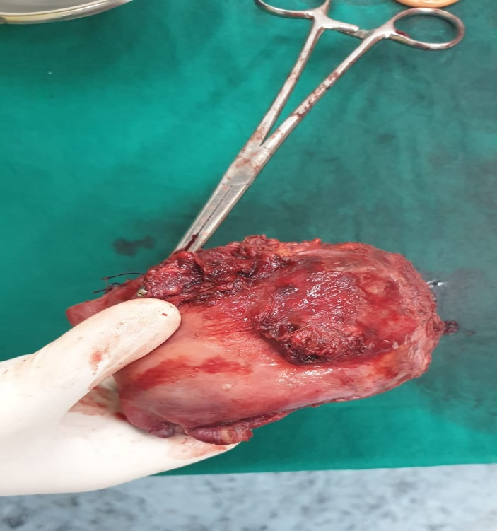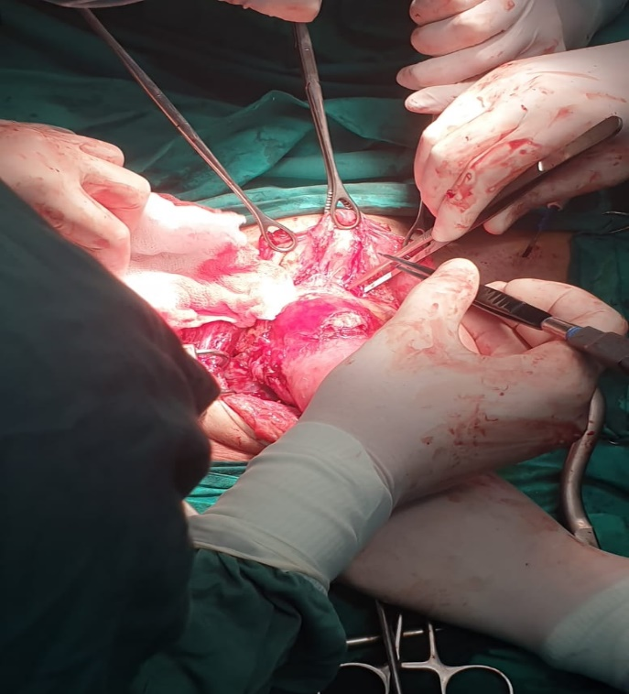
During the days on call I was also able to assist in the management of the emergency department as well as the delivery room. A resident's guard duty lasts 24 hours.
I also had the opportunity to attend the Perinatology meeting that is done once every 3 months where a resident collects the most interesting cases of the last months and there is a fruitful discussion between gynaecologists and neonatologists. I found this meeting very productive for them as instead of going against each other they were trying to find common ground for the good of the patients.
On the oncology side, it is likewise a department of excellence that I have followed less for reasons of strictly personal preference. It is an ESGO and IOTA accredited centre.
They perform high-level oncological surgery, benign gynaecology, hysteroscopy, breast surgery.
They perform tumour board meetings for the multidisciplinary assessment of the most critical oncological patients.
Both Professor Dinas and Professor Petousis and the whole team are very professional, good and didactic explaining the various cases, removing the cultural barrier in case one does not know greek.
Papegeorgiou Hospital
Thanks to Sofia Tsiapakidou I also had the opportunity to attend Papageorgiou hospital on Friday morning where I mainly attended infertility thanks to the kindness of Professor Kolumbianakis who allowed me to observe their activities. I have seen transfers, pick ups, the various ovulation induction protocols and ultrasound-laboratory follow ups. After the activities I also saw some benign surgery thank to the Professor Grimbizis as this is also a renowned center for surgery. Sofia has always helped and supported me in moments of discomfort that necessarily there are when you are away from your country. We also shared good moments in the hospital but also in Greek restaurants. She is a responsible, serious person who you can count on. I will always be grateful for her friendship.
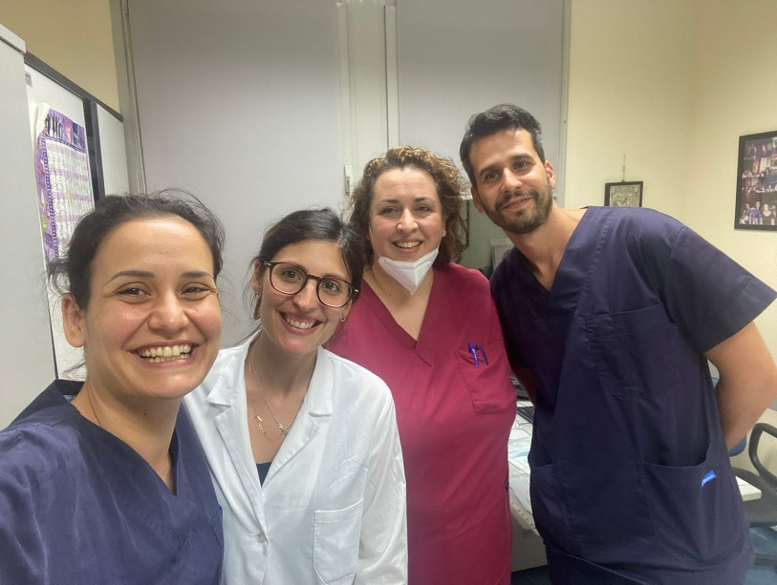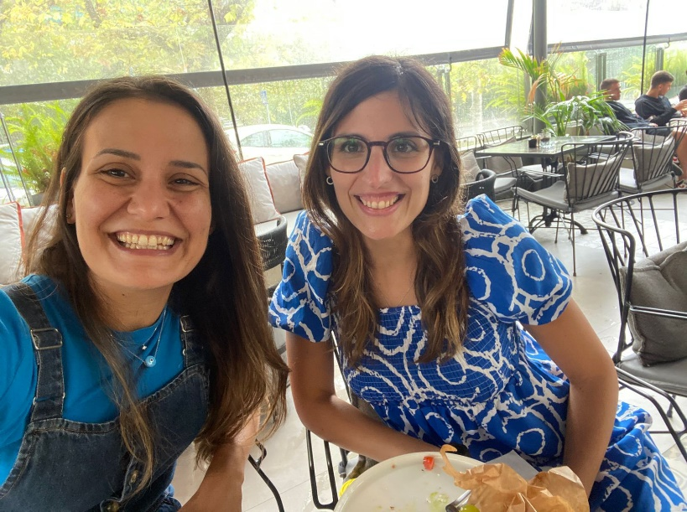

Finally, I wish to express again my gratitude and sincere thanks to ENTOG, EBCOG for this amazing opportunity and the Professor Sotiriadis, who has been my main mentor during these months and to whom I will always be grateful for the precious teachings.
Kind regards,
Dr. Fabiana Interlandi

