Observations and Report of the Short-term Fellowship Granted by EBCOG
Dilruba Tureli
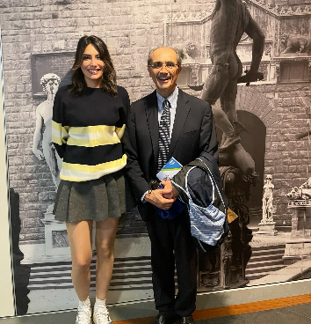
I would like to start this report by thanking Felice Petraglia, head of the department of Obstetrics and Gynecology,University of Florence and his team. I could not have imagined a more productive 3 months.
I was thrilled to meet Prof. Dr. Felice Petraglia, whose work on endometriosis I had long admired. I sought his guidance for a fellowship program that aligned with my career aspirations.From the beginning, he provided invaluable support, immediately responding to my emails and offering personalized guidance. He considered my dreams and wishes, from my accommodation plan to the weekly plans for the next 3 months.After my first day at Careggi Hospital, a weekly plan was made.A detailed program was prepared with a focus on endometriosis, PCOS, reproductive physiology and infertility.During this period, I attended detailed trainings on conservative treatment, follow-up and ultrasound evaluation of endometriosis and adenomyosis. I participated in patient follow-ups in outpatient clinics and had the opportunity to follow minimally invasive interventions. Felice Petraglia's daily supervision and guidance were instrumental in my development. He mentored me in writing medical publications and taught me how to write a publication from the beginning to the end.I was involved in writing three publications in the three-month period I was there.
I participated in numerous university panels on menopause and gynecology, and I personally helped prepare the presentations for one of them.Thanks to the tolerance shown during my stay, I had the opportunity to follow congresses in other countries, including the 33rd ESGE congress in France, Marseille. With Felice Petraglia's support, I also attended the National Congress- SIGO2024 in Florence, where I had the privilege of meeting many distinguished professors and experts.
During my stay, I took the EDSRH-EBCOG/ESCRH exam and earned the EDSRH-EBCOG/ESCRH diploma, which confirmed my Sexual and Reproductive Medicine knowledge.
With Felice Petraglia's guidance and support, I completed my SEUD, ESHRE, ISGE, and ISUOG memberships and expanded my knowledge by participating in panels.
I returned to my country with the new friendships, knowledge, and determination to achieve more. It's hard to imagine how I could have made this experience more effective.
The EBCOG fellowship was an ideal experience and a great opportunity to get a different and valuable notion. I strongly recommend EBCOG to continue to support international exchange among the trainees and I highly recommend this clinical fellowship to the young gynaecologists and obstetricians. Special thanks to Dr. Felice Petraglia and his team who not only organized my training program in the hospital, but also helped me with all the everyday difficulties.

