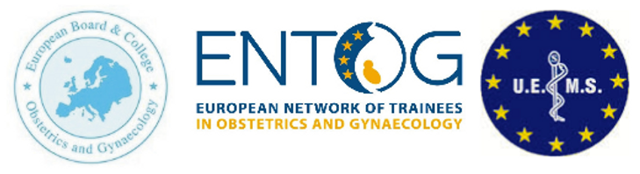
ENTOG-EBCOG Fellowship 2025
Dr. Inês Castro – PORTUGAL
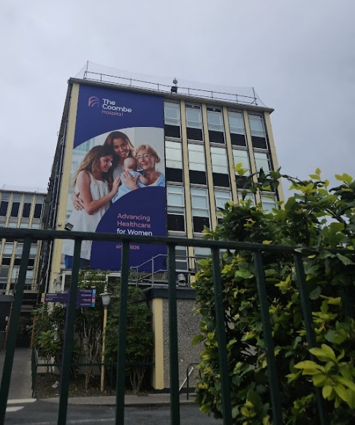
From July to September 2025, I had the opportunity to learn as a trainee at The Coombe Women and Child University Hospital in Dublin. This clinical observership was made possible by the ENTOG-EBCOG Fellowship, to whom I express my gratitude for such enriching experience. My name is Inês Castro and I am a 5th year resident doctor from Porto, Portugal, established at Centro Hospitalar Universitário do Porto – Centro Materno Infantil do Norte. During our training in Portugal, we get the opportunity to do 12 months elective national or international training, so I applied for this 3-month fellowship as a way to fulfill and compliment my core training. I was very well received at The Coombe, and these 3 months definitely gave me new skills for my future as an European Specialist in Obstetrics and Gynecology. I would very much like to thank the Coombe Master Professor Michael O’Connel for accepting my short-term fellowship in 2025.
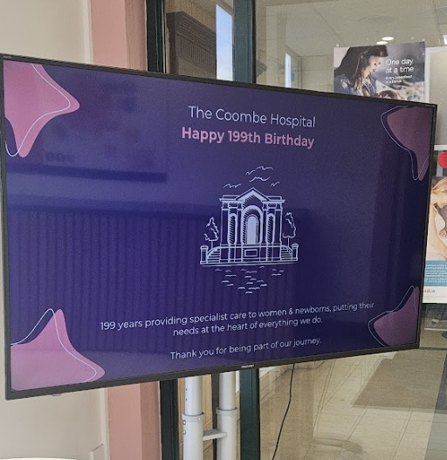
The Coombe Hospital has been offering care to women and newborns for the past 199 years and is part of the HSE (Health Service Executive) including public, semi-private and private patients. In 2023 there were 6974 deliveries and 6042 Gynecological Surgical Procedures with an increase in outpatient hysteroscopy and colposcopy clinics in the last years. In January 2023, The Coombe Hospital became the first hospital in Ireland to be accredited by the European Board College of Obstetrics and Gynaecology (EBCOG) for Maternal-Fetal Medicine training and is also accredited for General Obstetrics and Gynecology.
Given my interests, I spend most of my internship in the Gynecology Department. The Coombe Hospital provides the largest benign Gynecology service in Ireland with specialized clinics for Colposcopy, Complex Menopause, Endometriosis, Fertility, Fibroids, Adolescent Gynecology, Outpatient Hysteroscopy, Urogynecology and Recurrent Miscarriage. I had the opportunity to be mentored by Professor Nadine Farah with whom I spent most of my internship, however I was also very well taught and received by Dr. Workineh Tadesse (Outpatient Hysteroscopy/Ultrasound, Laparoscopy theatre, Fibroid clinic), Dr. Niamh Murphy (Adolescent and Pediatrics Gynecology) and Dr. Zeinab Barry (Complex Menopause) every week. During the first week of training, I shadowed a Specialist Registrar (5th year post graduation) so I had the opportunity to observe day-to-day life of a trainee with Obstetrics and Gynecology clinics, Delivery Suite, Theatre and Education meetings. In the Coombe there are four weekly meetings – Monday teaching sessions led by a consultant, Tuesday CTG meetings, Wednesday Maternal-Fetal Medicine Meetings and Friday Journal Club.
During my stay I had the following schedule:
 | Monday | Tuesday | Wednesday | Thursday | Friday
Morning | EPAU | Outpatient hysteroscopy | Operating Theatre | Outpatient Hysteroscopy/Colposcopy | Colposcopy Clinic
Afternoon | Recurrent Miscarriage Clinic or Fibroid Clinic | HyCosy (Fertility Hub) | Fertility Hub or Pediatric Gynecology | Adolescent Clinic
Evening |  |  | Complex Menopause

EPAU:
The Early Pregnancy Assessment Unit (EPAU) had a total of 4101 attendances in 2023 and is fully dedicated to assessing early pregnancy and its complications (pregnancy of unknow location, gestational trophoblastic disease, miscarriage, ectopic pregnancies or high risk for these diagnosis). There are daily ultrasound and counselling periods and medical and surgical treatments including ERPC (Evacuation of Retained Products of Conception) and MVA (Manual Vacuum Aspiration) are provided. During my stay I observed multiple ERPCs and MVAs as well as laparoscopic salpingectomies. I would like to thank the EPAU team, especially Prof. Nadine Farah, Dr. Emma Sheehan (Fellow of the EPAU), Nadja and Claire.
Office Hysteroscopy/Ultrasound:
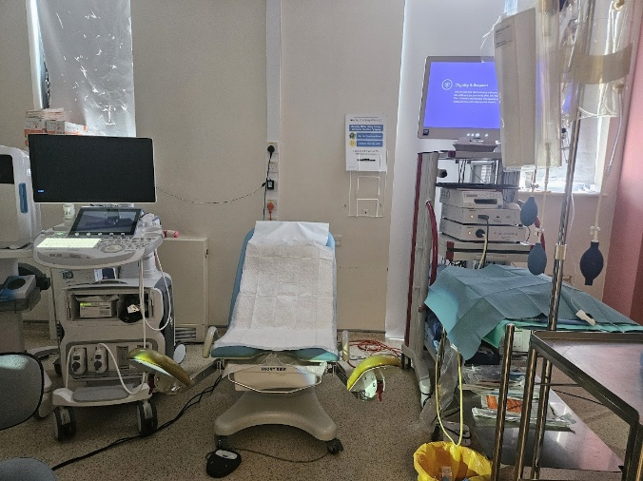
The Outpatient Hysteroscopy Clinic assesses women with postmenopausal bleeding or abnormal uterine bleeding. Patients undergo assessment using a ‘one-stop’ appointment model of care, integrating transvaginal ultrasound, hysteroscopy (if indicated following scan), and endometrial biopsy. In some cases, colposcopy can also be performed. I had the opportunity to observe two cases of endometrial cancer, as well as multiple polyps, endometrial hyperplasia, and fibroids. Most cases had treatment in the office setting, mainly with Myosure. Other cases where then referred to theater where I also had the opportunity to observe endometrial ablation with Novasure. It was a very interesting model since most patients could get diagnosed and treated on the same day, and most were discharged after a virtual appointment for histological results some weeks later. I would like to thank the consultants Prof. Nadine Farah and Dr. Tadesse and the Fellow of Benign Gynecology Dr. Eimear McSharry for the time, sharing of ideas and training in this clinic.
Fertility Hub
The Fertility Hub provides advice, blood tests, ultrasound scans, tubal patency tests, semen analysis, fertility-related surgery, and treatments such as ovulation induction to couples with infertility. During my stay I observed weekly the assessment with these couples, as well as the realization of HyCosy and fertility related surgery, mainly diagnostic laparoscopy and hysteroscopy. I had the opportunity to observe Prof. Nadine Farah and her team of specialist nurses (especially Sinead and Eve) and specialist registrars, as well as Dr Lucy-Ann Behan, Consultant Endocrinologist, dedicated to Reproductive Endocrinology, who very much welcomed me in their practice. Referral to publicly funded intrauterine insemination (IUI), in-vitro fertilization (IVF) and intracytoplasmic sperm injection (ICSI) treatments was provided through this clinic.
Pediatric and Adolescent Gynecology
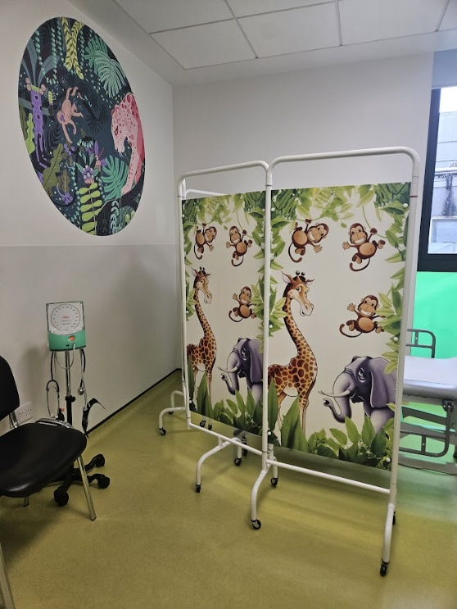
The Coombe Hospital is one of the three Irish hospitals with a dedicated Pediatric and Adolescent Gynecology (PAG) service, established by Dr. Niamh Murphy in January 2023. The PAG team (Consultant and SpR) at The Coombe Hospital also attend the PAG clinic in Children’s Health Ireland (CHI) at Temple Street, where care is offered to younger patients <16 years old and I had the opportunity to join this clinic as well. Referrals included adolescents with menstrual concerns, ovarian masses, disorders of sexual development, Mullerian anomalies, precocious or delayed puberty and premature ovarian insufficiency. I had the opportunity to observe premature ovarian insufficiency caused by galactosemia, a condition more prevalent in the Irish population, with an estimated birth incidence of about 1 in 16,500 in the general population, and a higher rate of approximately 1 in 450 within the Irish Traveller community. For comparison in Portugal it affects between 1 in 30 000 to 1 in 60 000 new-borns. I also had contact with children and adolescents with dysmenorrhea and heavy menstrual bleeding, primary amenorrhea, vulvovaginitis, foreign bodies and Mullerian anomalies as well as post-operative evaluations. I would like to thank Dr. Niamh Murphy and her team for welcoming me in their practice.
Complex Menopause:
The Complex Menopause clinic is a evening weekly clinic run by Professor Michael O’Connell, Dr Zainab Barry and Clinical Nurse Specialist Claire Brown. The most common indication for referral was a personal history or a family history of hormone related cancers, but other complex medical situations such as previous thrombosis, heart conditions, endometriosis or difficult management in primary care were also indications. The patient had a first evaluation and sometimes started therapy (HRT or non-hormonal) on the first appointment, other times after investigation for specific conditions. After that first appointment usually the revaluation was made by phone call. I had the opportunity to join the British Menopause Society certification during this period and really thoroughly learned how to access and treat menopause symptoms with much more confidence. I would especially like to thank Dr. Zainab for teaching me every week.
Colposcopy:
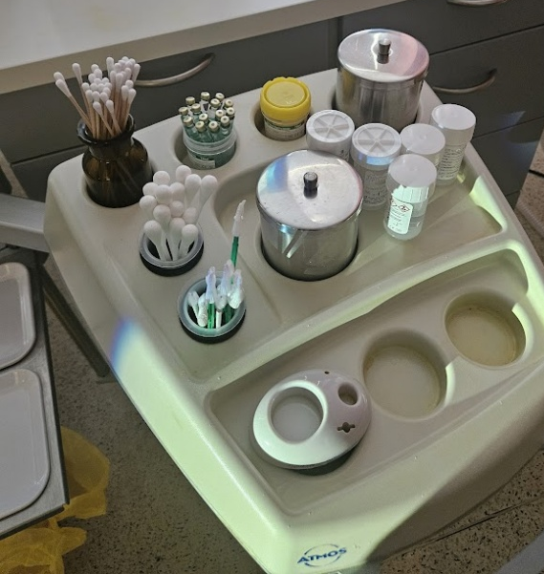
I had the opportunity to observe Prof. Nadine Farah weekly Colposcopy Clinic on Friday mornings. The Coombe Hospital is home to the National Cervical Screening Laboratory (NCSL). During these clinics I could completely observe the procedure, since the colposcopes have a camera system, and could discuss every colposcopy with the consultant. I found very interesting and humane how the patient is treated in a way to decrease discomfort, especially by using alternative pain management techniques such as stress balls, warm water bottles as well as the conversation with the health assistant. The patient can also fully follow their own examination if they prefer through the camera. Cervical anesthesia is provided for all the procedures, including not only LEETZ but also use of forceps or biopsies. I had the opportunity to view high grade cases, including adenocarcinoma in situ. I would like to thank The Women’s Health Department team, especially Maya and Eimer as well as Dr. Elizabeth Tunney (Specialist Registrar) who made me feel part of the team every day.
Differences in training:
I did find some differences in the Obstetrics/Gynecology training program. In Ireland there is one year post-graduation (intern year) where there is more generalist and elective training, and then the young doctor applies to Basic Specialist Training (BST) to be a Senior House Officer (SHO) for two years followed by one year as a Junior Specialist Registrar in a specific specialty. After this there is a new application process for Higher Specialist Training (HST) to become a Specialist Registrar for 5 years and after that to finally be a Consultant. Another difference is that residents only stay in the same hospital for 6 months-1 year (rarely more than that), depending on what each hospital needs and the need of each trainee. Some people also do more research vs clinical work. This is a very different system from Portugal where the training is for 6 years after a similar intern year, but there is only one application based on an exam and the resident stays affiliated to the same hospital until the end of training. However, training itself is indeed similar and after talking to other residents the number of procedures and surgeries done at the end of training is equivalent. I had the opportunity to join a group of registrars in an immersion program for interns at the Royal College of Physicians of Ireland and discuss a bit of the training program, invited by a local SpR.
Differences in day-to-day life:
Medical and surgical practice is very similar, especially concerning surgical technique and treatment plans – we all follow very similar guidelines! I very much enjoyed seeing a different approach to pain management for gynecological procedures, and how a small thing such as a stress ball and a clinical assistant to keep the patient calm and relaxed can help so much. The use of local anesthetics, especially cervical and paracervical block is much more common for small procedures, such as IUD insertions. Nurse specialists and midwives also have a quite different role in day-to-day life as they are certified to scan, do colposcopy and hysteroscopy, as well as some prescribing, whereas in Portugal midwives and nurses only have that type of autonomy while assisting spontaneous vaginal deliveries. I really enjoyed learning and working directly with them, as part of the team. It was very interesting to get to know another public health system, there are many similarities as well as differences and it really does make you feel a part of a very big European team in a world where borders and nationalities are in constant change and merging.
I would very much like to thank EBCOG and ENTOG for this extraordinary opportunity to be a European fellow in 2025! I will take so much of these 3 months to my clinical practice in the future and I hope you can keep up with this incredible program in the future! Thanks again to every single person who received me as part of the team at The Coombe!
